Product life cycle task 25.10.2018
Teams will make product life cycle description of their own original product. The description will contain a visualization of the product life cycle and explanation of the product life cycle stages. The report should reveal the major environmental and health impacts during the product life cycle.
- Visualization of the product life cycle (presented 8.11. session)
- Table of the environment and health impacts during the life cycle (example below)
- Date sources & evaluation of the reliability of the data, comments on missing / uncertain data, basis for own evaluations
- Clearly stated conclusions on the major impacts during the product life cycle. This will indicate likely target of improvement(s) (if found feasible / possible)
Product life cycle impacts are summarized in a table, which lists inputs (what is needed in the stage) and outputs (products, by products, waste, emissions) of each stage.
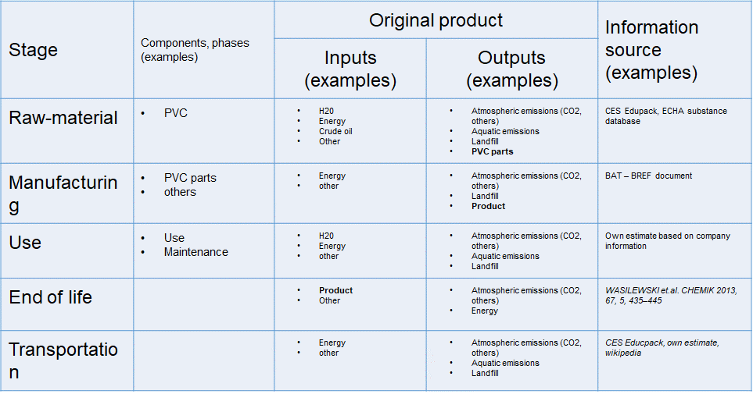

Report (visualization & description) will be submitted in Aalto Open Learning Group Forums and assignments in “Product life cycle-report”-section. Deadline is 8.11. at 12:00.

